**Please type your responses below each question. Thank you!**

1. **Do we have your permission to include a summary of your responses in our book**, which may include quotes, your name, title, institution, department, and any other information included below? Please type “yes” or include any questions here.

Yes, here is my info:

**Firas Moosvi** ([He/Him/His](https://equity.ubc.ca/resources/gender-diversity/pronouns/))

Lecturer

Department of Computer Science, Mathematics, Physics, and Statistics

The University of British Columbia | UBC Okanagan | Syilx Okanagan Nation Territory

3333 University Way | Kelowna BC | V1V 1V7 Canada

firas.moosvi@ubc.ca | @[FirasM](http://twitter.com/FirasM)

[https://firas.moosvi.com](https://firas.moosvi.com/)

1. **Please describe yourself and your institutional context:**
   * Briefly describe your position and how long you have been there (e.g. pre or post tenure, non-tenure-track, adjunct, etc.):   
       
     I am currently a Lecturer (teaching faculty, but not tenure track yet) and have been teaching in this position about 3 years.
   * Your institution’s name:   
       
     University of British Columbia Okanagan (satellite campus of UBC Vancouver)
   * Brief description of your institution (e.g. “selective liberal arts” or “research-intensive public university”):  
       
     My campus (UBCO) is small, roughly 11,000 undergraduate students, but the main UBC campus is 56,000 undergraduate students. The university (overall) is a large (by Canadian Standards) [research intensive institution](https://www.ubc.ca/about/facts.html).
   * Brief description of your department (e.g. how many students?):  
       
     The department has about 750 students across several disciplines: Computer Science, Mathematics, Physics, and Statistics. This is somewhat unique across universities in Canada and is mostly a historical artefact based on the campus’ smaller size. The largest class in the department is about 300 students, and the average class sizes are much smaller.
   * Is there anything else you’d like us to know about your position, department, or institutional expectations or support?  
       
     My PhD was in Physics, but I also have practical computational experience as well. I now teach computer science, data science, and physics. My position is almost completely teaching focused and I teach 6 semester-long (13 weeks) courses a year. However, I am doing a lot of “educational leadership” in my position because I am interested in alternative assessments and pedagogies.
2. **Please pick *one* class in which you’ve used alternative assessments and send its syllabus to** [**gradingforgrowth@gmail.com**](mailto:gradingforgrowth@gmail.com) (or include a link to a shared doc here). If you use similar ideas in multiple classes, pick one that best represents your ideas.

**Link to Syllabus:** <https://firas.moosvi.com/courses/2021_WT1/data301/about/unsyllabus.html>

I’ll also email it to you David in case you want a PDF.

1. **Describe the basic data for the class:**
   * Class number and title:   
       
     COSC 301 - Introduction to Data Analytics
   * Brief description of its content or purpose:   
       
     COSC 301 is one of my favourite courses to teach at UBCO! It is a fantastic introduction to the field of Data Science and in this one course, students will be equipped to handle many common data wrangling, processing, and analysis tasks. Students will also be introduced to a variety of tools (tech stack) that are common in the industry, and we hope you use this course as a springboard to launch their interest in Data Science!

The course learning outcomes are:

* 1. Understand data representation formats and techniques and how to use them.
  2. Work with large datasets and learn to manipulate them programmatically.
  3. Experience using a wide-range of data analytics tools including Excel, Git, Python, Pandas, Tableau, and other visualization packages and software.
  4. Develop a computational thinking approach to problem-solving and use programs to solve data tasks.
  + Typical class size:   
      
    175 students
  + Externally imposed limitations or requirements (e.g. a required common final):   
      
    Students must get a numerical grade, on a scale of 0-100 by the end of the course with 50 as a passing mark.
  + Number of times you’ve taught it:   
      
    Have taught it three times already.
  + Is there anything you’d like to share about how you teach this class *besides* the assessment system? (e.g. flipped class, community-based learning, etc.):  
      
    - It’s a standard active learning class, with clicker questions (not for any marks), some lecturing, occasional exercises and tasks for people to do in breakout rooms (not for marks).  
      
    - Some flipped classes (where students watch professional videos and then come to class to practice), mostly interactive demonstrations of various programming skills including Python, Pandas, data visualizations, analysis, etc…

1. **Describe the general features of your assessment system.** Please share your thoughts or reasoning behind each key aspect of the system.  
     
   ***Note: I also do full Ungrading in a couple of my classes, but I think for the purposes of this, I chose a course that is a bit less radical and inches towards alternatives to traditional grading that are supported by lots of literature.***  
     
   Overall, the best way to describe my assessment system (currently) is a cross between traditional grading, standards-based grading, and ungrading. I try to de-emphasize grades as much as possible. In some cases, by separate grading and feedback - and in other cases, giving students multiple opportunities to re-submit the same assignment until they meet specific standards. The “traditional” part of the grading system is for things like the tests and the final exam, where it’s only a one-shot, timed assessment with no opportunity for resubmission.  
     
   Below are some key features:

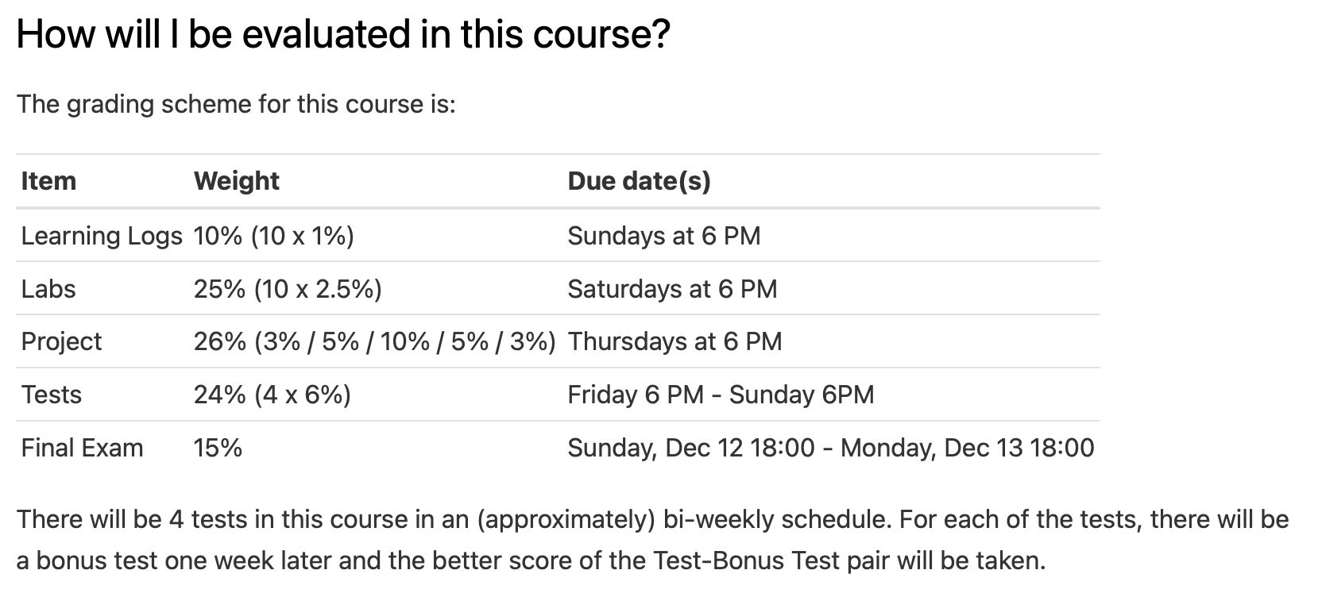

1. **Frequent Testing**  
     
   Rather than the traditional assessment model of 1 or 2 high-stakes midterms in the course, I adopted a frequent testing paradigm in this course. Students are required to do 4 low-stakes tests (roughly once a month in a 4-month semester). Each student’s test is reasonably unique as the test questions are randomly drawn from a test bank. This allows me to do two things: A) give students a 48-hour window during which they need to complete the one-hour timed test and B) give students an opportunity to do a “re-test” (I call it a Bonus Test) one week after the original test with a new set of randomized questions. I take the better of the Test/Bonus Test scores, so they are never disadvantaged from doing more tests.
2. **Grades (temporally) divorced from feedback on Labs**

Several studies have shown that if students are given their grades alongside their feedback, regardless of how much effort and time went into the feedback, students will focus on their grade. In addition to the obvious problem with this approach, at the end of the day, students don’t review their labs and learn from their mistakes; in fact, they continue to make the same mistakes in subsequent labs.  
  
To (try to) fix this, here’s what I do:

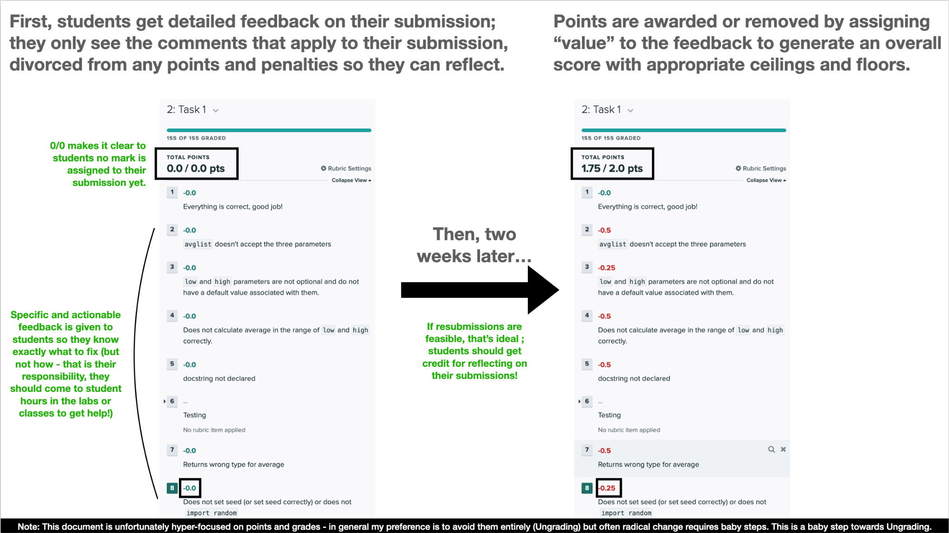

1. **Weekly reflection opportunities (for credit) - Learning Logs**

Of all the things I do currently in my courses, I am most proud of the Learning Logs. Each week, I give students a very short assignment (advertised as 30 minutes or less) asking them to reflect on their learning in the past week in a very guided way. The assignment is very structured:

1. Question 1 is usually a content-related question asking them to think a bit more deeply about an example we discussed in class, a homework problem, or some other extension that synthesizes information from a variety of sources.

2. Question 2 varies by class - in my intro physics classes I ask them to share a screenshot of their formula sheet (the first question in this series teaches them how to make a formula sheet). In computer and data science classes, students reflect on their recently submitted lab and discuss which parts they enjoyed, which parts they struggled with, and whether their struggle was a productive one or not. They also assess themselves a grade for the work they did that week.   
  
*Note: For the past 2 terms, I have been collecting this data (students’ self-assessed grades on their submissions) as part of a SoTL study to compare their self-assessments vs. their actual awarded grades, and see if the difference decreases over time. I’m also interested in exploring equity issues in self-assessments - are certain subpopulations in my class harder on themselves than others?*

3. Question 3 is a well-being check where I ask students about their current and expected anxiety and stress levels. Students can opt-out of answering these questions and still get credit for it.

4. Question 4 is an optional open-response question where I ask students if there is anything else they want me to know about, or anything they want to ask me. The most typical response here is nothing, or to wish me a good day or weekend. Occasionally I get to hear about how students are doing, what they thought of the week, complaints about the test or HW being too hard, a funny joke, or some other insightful reflection about life as a student. The weekly learning logs really are the best part of my week!

1. **Flexible deadlines**

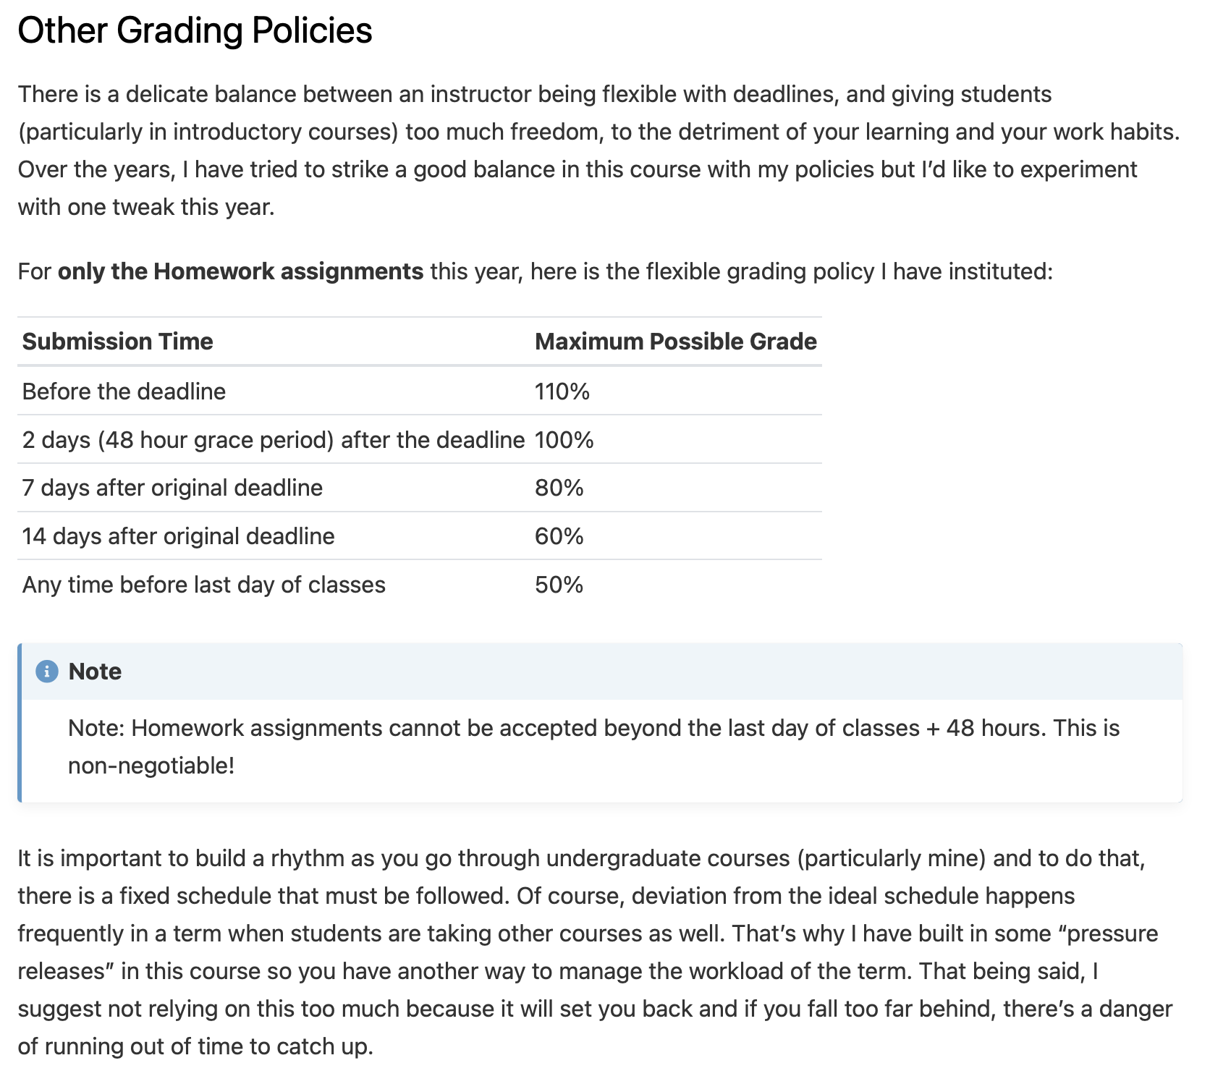

1. **What are some specific benefits or successes** you’ve noticed with this system?

* Faster, more stream-lined grading by multiple TAs
* Overall, far fewer regrade requests (those that are submitted are usually legitimate grading errors rather than complaints about too strict penalties)
* Economy of Scale - feedback comments can be recycled between course offerings, and each time the comments are improved to be more specific and targeted
* More thoughtful teaching (learning analytics reports on common student knowledge gaps that I can cover during live classes
* Far fewer extension requests!
* Happier and more reflective students

1. **What are some specific difficulties or failures** you’ve had while using this system? Do you have any advice on how to avoid them?

* Some students don’t look at it until there is a grade associated with it and ignore the feedback entirely.
  + Make it a point at the beginning, middle, and end of the term to remind students about the perils of grading, and the philosophy/pedagogy behind alternative grading practices
* Workload of the teaching team generally increases compared to the standard 2 midterms + a final exam. The workload is often hard to predict week-on-week.
  + Autograding is the solution here! Need to write code so that as much as possible, the code is auto-graded. Unfortunately, this takes a significant amount of overhead to set up initially, but is worth it in the end. Some questions will always need to be manually graded, but reducing the number of these will increase the quality of feedback that can be provided for the few manually graded questions.
* Somewhat higher grades (mostly coming from the Test/Bonus Test system)

1. **How much time and work** did it take to convert this class to this assessment system the first time? Has it taken additional work since then?

* Creating the Test Bank and having enough questions for 4 Tests and Bonus Tests was perhaps the most challenging and time-consuming part of this.
* Developing material and creating a course website that explains these ideas was the next most challenging aspect
* It was a fair bit of work but I was about to change all of my courses (Computer Science, Physics, Data Science) to this system. I did a few things to make it more manageable by:   
    
  1) adopting open educational resources.   
    
  2) using help offered by the institution intended to transform courses to “online” offerings, by simultaneously redesigning the courses to adopt a pedagogy of care.

3) Auto-grade 80-90% of the Tests and Bonus Tests to save TA time and use some of it to help with course development “on-the-fly”.

* Hard to say if it’s taken additional work as we always keep adding, tweaking, changing, and experimenting. The work definitely has gotten a lot more focused.

1. **Are there any intentional choices you’ve made with respect to assessments** that you think others in a similar setting should know about? Please explain.

* I think I added a lot of detail above so probably not helpful to duplicate that here.

A few comments from my teaching evaluations from this course:

“The structure of it is nice. I enjoy how he actually cares about us learning the content vs. getting good grades on the content”

“Very detailed yet not too overwhelming for someone who's not adept in coding. It was very educational and strongly believe that I can further my knowledge in this matter should I choose to do so because of the strong foundation this course has given me. The instructor also tried his very best to foster learning more than reducing students to tests and memorization which is greatly appreciated. Overall the course is highly educational and the prof is both knowledgeable and understanding.”

“The way this course is delivered is learning–oriented. These 6 weeks has been one of the most productive in terms of learning knowledge. Another point to address is the fact that the course grade is not revealed until last week has been working well! Some stress is created by not knowing if we are on a bad standing or not, but it does shift the focus back to learning rather than chasing for grades.”

“Amazing professor, very caring about his students success. This course is very well sorted due to Dr. Moosvi taking time to blend the classes and the labs as seamlessly together as possible. Dr Moosvi is truly an amazing instructor, one of the best I have ever had at UBC Okanagan. THe timetable is clearly laid out, and the concept of bonus tests is excellent for learning as it allows the student to re–examine previous course material and have a greater retention, as the student has a greater understanting of that material when having been exposed further to said course material. Let me point this out again, one of the best professors I have ever had at UBC Okanagan.”

“I enjoyed that we were exposed to a different type of learning. Where we weren’t so focused on grades and instead focused on our feedback”

“Honestly, it was so refreshing to have a professor who actually emphasized the learning aspect of a course instead of just pushing us to achieve a high grade. I feel like I learned and retained so much more given this learning mindset compared to the classic memorize–and–regurgitate methods. This was a challenging course given how much we had to learn over the period of 6 weeks, but I think Dr.Moosvi communicated the course work in an efficient manner and flawlessly adapted to any issues that arose regarding coursework.”